Name of the Employee | Patricia Mae L. Minimo
Job Position | Marketing Officer I
Department | Marketing
Date of Exit Interview | April 28, 2026
Conducted By | Katrina Pauline M. Trinidad

SUMMARY

Reason for Leaving | Justification
Better Job Opportunity and Dissatisfaction with Management | Pat mentioned that she is currently looking for better job opportunities and the reason why she was dissatisfied with the management, it’s because there was no communication during her resignation.
Job Satisfaction
- Job Role | She shared that she really enjoyed what she handled and it was very fulfilling.
- Work Environment | MJ shared that she was satisfied with the work environment and she sees the relationship with her colleagues and management are good.
- Management | MJ expressed her dissatisfaction due to no guidance from her head and she felt alone.
Feedback and Suggestions
What did you like most about working here? | “What I valued most was the strong sense of teamwork among colleagues. They made the day to day work more manageable and enjoyable. I also appreciated the company culture, which fostered collaboration and a positive working environment.”
What aspects of your job or the company could be improved? | “There is room for improvement in leadership alignment and communication. Additionally, streamlining approval processes would help increase efficiency and allow teams to move forward more quickly.”
Do you have any suggestions for improving the work environment, culture, or employee benefits? | “It would be beneficial to implement structured mental health support, such as regular check-ins or wellness programs, especially for employees experiencing burnout. Proactively addressing employee well-being can help improve morale, productivity, and employee retention.”
Final Comments | “I truly value the relationship I’ve built both inside and outside the office. The people are one of the company’s greatest strengths and key contributors to its success. I hope the company continues to prioritize and support employees' needs, as investing in people is essential to sustaining growth and a positive workplace.”
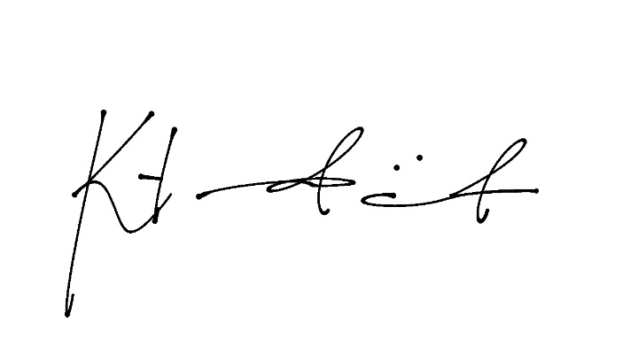
Prepared By:

Katrina Pauline M. Trinidad
Head of HR Department

